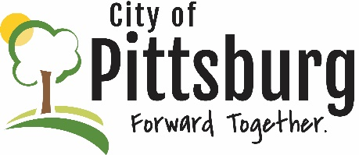
Sustainability Advisory Committee
Notes from
September 20, 2022 5:30PM
Meeting location: City Hall
Present: Jim Triplett, Denise Fitzpatrick, Andrew Ouellette, Jay Byers
Approval of the Agenda
Unanimously approved
OLD BUSINESS
Recycling Center Update
The Recycling Center Board has agreed to name its primary building after Dr. Triplett in recognition of his many years of commitment to establishing and sustaining the Center; the Center is undergoing a strategic planning effort led by Monica Murnan of Greenbush, they will attempt to increase wages and provide more stability in funding and operations; they are interested in potentially salvaging and selling construction debris, perhaps creating a materials barn that can create something akin to the Habitat store
Fall Event
The SAC is considering coordinating a potential activity with the newly formed National Institute of Materials Advancement (NIMA) at PSU for World Science Day and Recycling Day; goal would be to focus on sustainable science efforts
Membership
There are open positions on the Committee and there is interest in working with the City’s PIM on a campaign to recruit new members; potentially asking Matt O’Malley; there may be value to having a social event to identify potential committee members;
Sustainability Marketing
Still need results of marketing study work by Lunde’s students; Considering a push to get recycling containers around town – these are less prevalent here than they are in other communities; a social event (meet & greet) may be a good opportunity to improve the committee’s visibility; is there value to recycling election signs?; the Committee could sponsor a speaker; also a new community garden may raise awareness; there may be some value to having one or more of the members visit the schools to discuss sustainability issues; the Committee could sponsor a community cleanup; should review if there are other groups doing sustainability work

NEW BUSINESS
Jesse Gilmore from the Extension Office will be coming to the SAC in November to discuss native plants; would a Halloween costume exchange be viable?; is there some way to increase the number of rain gardens in the City?

OTHER BUSINESS
A short-term charging station is available – where would it best be located? Probably in the area of Block22; are there grants available to help with deployment?

