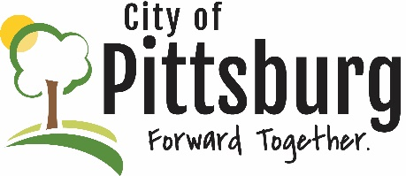
Sustainability Advisory Committee
Agenda
November 15, 2022 5:30PM
Meeting location: City Hall
Approval of the Agenda
SPECIAL PRESENTATION
Jesse Gilmore, KSU Extension Office – Native Plants and Grasses
OLD BUSINESS
Recycling Center Update
Fall Event
Membership
Sustainability Marketing
NEW BUSINESS
OTHER BUSINESS

