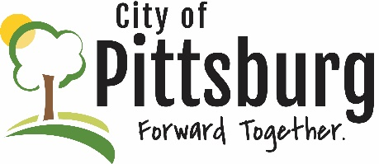
Sustainability Advisory Committee
Agenda
October 18, 2022 5:30PM
Meeting location: City Hall
Approval of the Agenda
OLD BUSINESS
Recycling Center Update
Fall Event
- World Science Day (with NIMA)
- Recycling Day
Membership
- Recruitment campaign (Matt O’Malley)
- Social event
- Speaker
Sustainability Marketing
- Social event
- School visits
- Community cleanup
- Working with other sustainability groups
NEW BUSINESS
Project Ideas
- Rain gardens
- EV charging station
- Costume exchange
- Recycling containers
- Community garden(s)
OTHER BUSINESS

