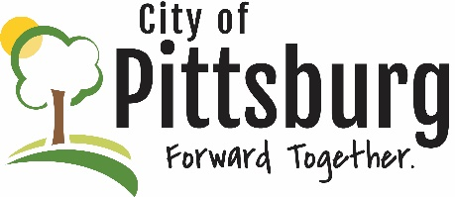
Sustainability Advisory Committee
Notes from
June 21, 2022 5:30PM
Meeting location: City Hall - attendees: JTriplett, GWeeks, AOulette, JByers
Approval of the Agenda - Agenda approved
Acceptance of Notes from 5/17/22 meeting - Notes accepted
OLD BUSINESS
Recycling Center Update
Triplett reported that the Center is doing well primarily due to increased commodity prices; their primary fundraiser is a golf tournament that will be held on 7/7/22; the are working on strategic planning and communication with Jeremy Johnson; they are considering buying out Ben Butler; they will be purchasing a new mower and a cooling system for the tunnel
Native Species in Landscaping
The City Attorney has indicated that there is no need to change our zoning regulations since all of the suggested changes are already allowed; effort should be made to promote the planting of native species; Byers to put together a meeting with SRunyon to discuss putting together a campaign
Quick Charge EV project
Triplett suggested that locating at least one EV station downtown would be the most appropriate spot and would like the Downtown Advisory Board to support one; the real need is for fast chargers; there should be grant money available for deploying them; Triplett recommended that the SAC promote adding charging stations
NEW BUSINESS
No new business was identified
OTHER BUSINESS
The Committee decided to cancel the July meeting due to vacation scheduling conflicts
There was interest expressed in capturing the data that Lunde’s students compiled for their class reports; this could be used to support a marketing campaign for the Committee; Triplett indicated that he would look into acquiring the data

