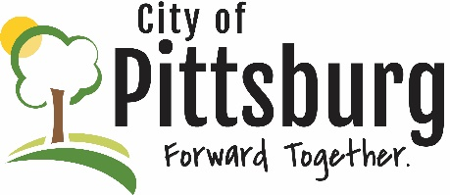
Sustainability Advisory Committee
Agenda
May 17, 2022 5:30PM
Meeting location: City Hall
Attendees: JTriplett, AOullette, MLunde, GWeeks, NScott, JByers
Approval of the Agenda
No new agenda items were added
OLD BUSINESS
Earth Day Recap
The group discussed the Earth Day event and were generally satisfied; the food vendor indicated that it was definitely worth their time to be there; no new people signed up for the pledge - other options will be considered
Sustainability Students Presentations
Some of the Committee members attended presentations by two groups of MLunde’s students; the students did small surveys about the community’s knowledge of the Committee and made suggestions about how to better market the Committee and its activities and mission; MLunde indicated that both student groups received As; the Committee will review and discuss the students’ presentations at a future meeting
Recycling Center Update
The Recycling Center has submitted a proposal for a waste oil heater to improve working conditions during cold periods; the center is currently in good financial shape, primarily due to the prices for recycled materials; there is a need for a grinder to facilitate plastics recycling; the center staff and board will be working through a strategic planning process; there is a need for a long-term sustainability plan
Native Species
GWeeks presented a suggestion for wording changes to Pittsburg’s municipal code 50-19; the Committee approved the suggestions; these changes can be proposed to the City Commission; there may also be a need to look at Article 40 of the Pittsburg Zoning book
Air Quality Monitor
The EPA was contacted regarding having a formal air quality monitor in Pittsburg; EPA indicated the State was responsible for developing monitoring plans; JByers has sent an email to the Kansas air quality department requesting a monitoring station; it may be necessary for the city to purchase its own equipment and manage its air quality monitoring
NEW BUSINESS
Quick Charge EV project
All of the charges in Pittsburg are slow chargers; we need fast chargers here; funds are available from the federal government for fast chargers, but they do require a significant match; a fast charger in the vicinity of Block22 would be a good location; there are chargers at the casino, but it is believed they are slow chargers
Open Dumpsters / Trash Codes
NScott stated that there are many instances where dumpsters are left open and trash is blown into the neighborhood; there needs to be some way to better address this issue; JByers stated that the city is not in the trash business – an attempt to have the city be responsible for trash was rejected by the City Commission; all the city can do is cite offending properties for nuisance code violations
OTHER BUSINESS

