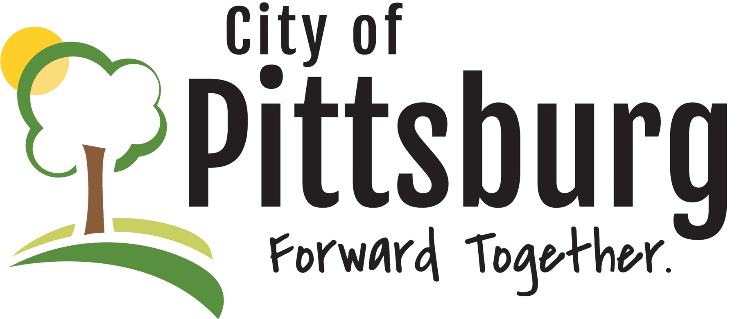

Located in the southeast corner of Kansas, Pittsburg is a thriving community of hardworking people. This forward-moving city is the place to put down your roots.

Why Pittsburg?
In Pittsburg we have the small town feel and family atmosphere with all the amenities as a large city, without all the busy hustle and bustle. Our city offers the very best in education, healthcare, sightseeing, outdoor activities, housing, work and more. We are home to friendly faces and welcoming people who are eager to see Pittsburg grow. Our community is focused on investing in the future with our forward-thinking attitude. We are moving forward together.
Investing in Success
Not only will you find a strong community in Pittsburg, but a place to build your life and to grow your family. We make decisions based on what is best for the people who have decided to plant their lives here, and they have repeatedly shown financial commitment to improvement. The citizens of Pittsburg have approved sales taxes for economic development, capital outlay, auditorium operations, and street improvements. In 2013, voters approved a sales tax to better fund public safety through the Police and Fire Departments, as well as a $31M bond package to add storm shelters and other improvements to school facilities. In 2021 voters passed a $16.5M bond package to renovate 72,000 square feet of the original 1921 high school, which now serves as the middle school. Approving these taxes has allowed the City to create a better, safer environment for everyone and shows the community’s willingness to take responsibility for its future.
Resident Well-Being
Pittsburg is proud to be the regional hub for healthcare in Southeast Kansas. Pittsburg is able to offer quality healthcare to all residents. We care deeply about the well-being of our neighbors and we make sure that the best care is available and accessible to everyone.
Educating our Youth
Education in Pittsburg is top-notch. We know the things we teach young people today will affect our city for years to come. Great education is a priority to us because it is a priority to the families that live here. The community of Pittsburg puts people first by putting time and money into things that matter. We are a small town with high standards and we are constantly pushing our city forward with growth and improvement.
Things to do
There’s always something going on in Pittsburg, from shows and concerts, to fitness and festivals. You can’t beat the local food and shopping in Pittsburg. Whatever cuisine you’re craving, you can find it in Pittsburg. The City of Pittsburg Parks & Recreation Department hosts classes, camps and activities all year long. Southeast Kansas has a rich history that emanates today in our everyday lives. Because of this, there’s a lot to learn and a lot to see. We make it easy to get involved with the community in Pittsburg by providing activities for everyone, no matter your interests.
Local Economy
The City of Pittsburg has a flourishing local economy and is the place to plant your roots and grow alongside the city. The cost of living in Pittsburg is well below the national and state average. We believe by balancing the cost of living and job growth, our city gives a quality of life that is unmatched.

Attractive Incentives for Housing Development

Progressive Evolution Demands Housing
With ambitious leadership and a strong partnership between the City, Pittsburg State University, and local businesses, Pittsburg is driving the greatest investment in economic development the City has ever seen. With this evolution comes a very basic and important need – homes.
Since 2013, Pittsburg has experienced:
- More than 1,700 new jobs with another 400 planned by the end of the year
- Over $500 million dollars of investment
- 10% average wage increase
Pittsburg currently has four housing developments underway including a 55 and over, maintenance provided retirement community, two planned residential developments and a third getting ready to start.
This kind of change and growth in Pittsburg supports professionals with good-paying career opportunities and creates demand for a variety of housing types. The City has incentives for all housing categories, with a particular emphasis toward the development of neighborhoods of high-quality single-family homes.
The City of Pittsburg, along with its Housing Department, continue to be motivated and are actively seeking additional partners in residential housing development. They are ready to go above and beyond to minimize risk to the right partner and may:
- Provide land at little or no cost, including access to the Land Bank
- Fast-track the removal of bureaucratic obstacles
- Coordinate federal and state incentive programs
- Customize incentives to the specific needs of development partners
- Consider ideas for new construction methodology and approaches
- Partner in consumer marketing to drive lot sales
This initiative is further supported by the Imagine Pittsburg strategic plan, which has established housing as one of four focus areas.

High Demand? Here’s Why.
In addition to the aggressive investment in economic development, which will continue to drive increased demand for housing, survey’s shows that Pittsburg is already feeling the impact of the shortage of affordable quality homes.
- Two-thirds of Pittsburg’s workforce live outside of Pittsburg and commute to the city each day
- 53% of respondents said that the reason they don’t live in Pittsburg is because of housing issues
- 75% of the Pittsburg workforce who earn over $90,000 annually, live outside of the city
A housing study conducted by Novogradac & Company in 2014 reported, “a lack of moderately priced homes in the area, where residents are either forced to wait a year for a home to be built, or they have to reside outside of Pittsburg to find quality moderately priced housing.” The study provided ten recommendations which include expanding the supply of moderate income housing and establishing neighborhood associations and planned subdivisions. While this effort is well underway, Pittsburg’s growth is outpacing the supply of homes.
A shortage of moderately priced homes combined with the largest investment in economic development the city has ever seen creates a significant opportunity for a variety of housing developments. The City is being aggressive and continues to talk to prospective developers.

RHID Eligibility Reduces Risk To Developers
Pittsburg has a qualified Rural Housing Incentive District (RHID) which will capture 100% of the incremental increase in real property taxes and reimburse those funds to the developer over a 25 year period. RHID reimbursement will offset certain land acquisition costs and multiple infrastructure costs.

