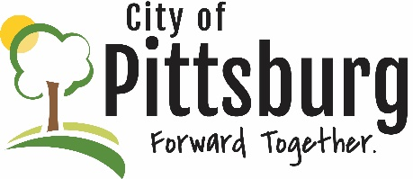
Sustainability Advisory Committee
Agenda
February 14, 2022 5:30PM
Meeting location: City Hall
Approval of the Agenda
OLD BUSINESS
Additional bus route public outreach
Earth Day
Air Quality
SEK Recycling Update and Outreach
NEW BUSINESS
PSU Sustainability Initiative
Clean Air Act
OTHER BUSINESS

