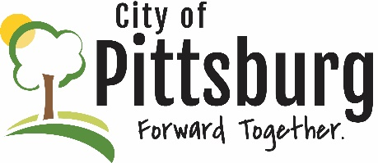
Sustainability Advisory Committee
Agenda
November 10, 2021 5:30PM
Meeting location: City Hall
Approval of the Agenda
OLD BUSINESS
Citywide Cleanup Update
Recycling Center Update
University Efforts Update
Green Award Program Progress
NEW BUSINESS
SAC Goals and Priorities
OTHER BUSINESS

