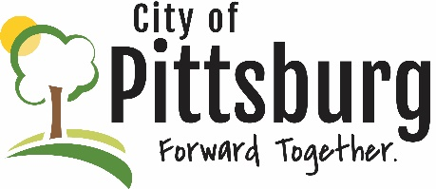
Sustainability Advisory Committee
Agenda
August 11, 2021 5:30PM
Meeting location: Online - https://global.gotomeeting.com/join/953560933
Welcome and introductions
Approval of the Agenda
OLD BUSINESS
Recycling Center Update
University Efforts Update
Public Transportation
Green Award Program Progress
NEW BUSINESS
Crawford County Solid Waste Committee Update
SAC Priorities
OTHER BUSINESS

