v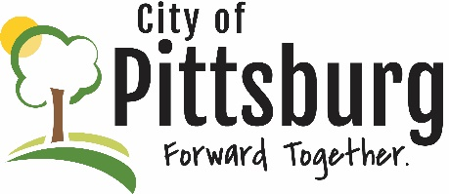

Sustainability Advisory Committee
Agenda
July 14, 2021 5:30PM

The July 14, 2021 Sustainability Advisory Committee meeting was canceled.
The next meeting will be August 11, 2021 at 5:30

