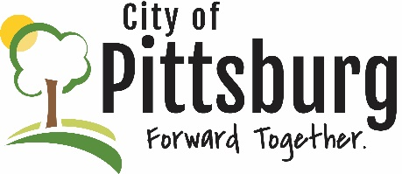
Sustainability Advisory Committee
Draft Agenda
June 9, 2021 5:30PM
Meeting location: Online
Welcome and introductions
Approval of the Agenda
Approval of Meeting Notes
OLD BUSINESS
Recycling Center Update
University Efforts Update
Public Transportation
Green Award Program Progress
NEW BUSINESS
Crawford County Solid Waste Committee Update
SAC Priorities
OTHER BUSINESS

