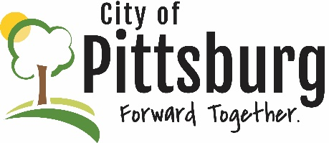
Sustainability Advisory Committee
Agenda
March 10, 2021 5:30PM
Meeting location: Online https://global.gotomeeting.com/join/530844829
Welcome and introductions
Attendees: Ouelette, Fitzpatrick, Scott, Weeks, Cochran, Bacon, Byers, LaVere
Approval of the Agenda
Approved by consensus
Approval of Meeting Notes
Approved by consensus
OLD BUSINESS
Recycling Center Update
Scott provided update; Board meeting tomorrow; working on online payment and web site; also looking for a membership hang tag; preparing a video for Earth Day
City’s New Wastewater Treatment Plant Progress
Bacon: Design continuing; waiting on flow information from Sugar Creek; still attempting to get funding; trees cleared; geotechnical investigation next week
Aquaponics Project
Update at next meeting
Public Transportation
Weeks: April to go back to Commission for PACT bus funding; 60 minutes showed that this is an unequal pandemic impact; some groups need more help with transportation than others

Earth Day 2021
Fitzpatrick: Turning it into Earth Week; using videos and other material on recycling center, stormwater management, 3rd and 5th graders providing artwork; Ouelette: create a pledge program; a proclamation;
MCP Update
Discuss at next meeting; some movement
NEW BUSINESS
Green Award Program

Review Annual MS4 Permit
Cochran: reviewing permit progress; web site has been updated to show current efforts and permit status; City has added a netting system and captured 2,100 ft² of solid material last year; reporting mechanism for illicit discharges; City tests storm water in two places (near Evergy to the west and near radio station to the east); numerous reports regularly prepared; 79 inspections of construction activity performed last year to hold contractors accountable for their environmental impact;
Could include water management as a challenge goal for the Committee;
OTHER BUSINESS
Fitzpatrick: Lots of litter in the town right now; promote cleaning up the City; LaVere will be planning events under the title #walkingoutofwaste; USD250 allowed kids to help a cleanup; Byers: City Cleanup is coming; coordinate these two; Scott: could work on neighborhood basis on a less formal basis; Bacon: look to target areas; Ouelette: how can we incorporate businesses?

