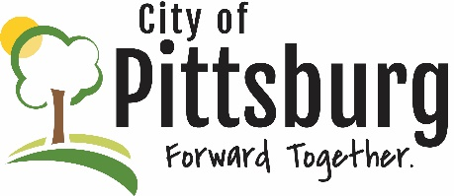
Sustainability Advisory Committee
Meeting Notes
February 10, 2021 5:30PM
Meeting location: Online
Welcome and introductions
Attendees: Triplett, Weeks, Scott, Fitzpatrick, Oulette, Byers
Approval of the Agenda
Passed by consensus
Approval of Meeting Notes
Passed by consensus
OLD BUSINESS
Recycling Center
Triplett and Scott provided information on the status of the Center and decisions of the board; Center is currently solvent but requires a long-term solution to remain viable
City/County Recycling Support
City and County remain committed to keep Center open; looking for a long-term plan that can be taken to the respective governing bodies
City and County Pandemic Response
Signs showing of a leveling off of Covid instances, though diligence will need to be maintained, likely for the rest of the year
City’s New Wastewater Treatment Plant
City continues to work on design and negotiate with largest user – Sugar Creek; tree removal/clearing has begun; funding still must be identified to avoid an unreasonable burden on ratepayers

Aquaponics Project – USD247 Progress
Progress continues; management and operations remain issues
Public Transportation
Neither the City or SEK-CAP are ready to start another bus route; plan is to prepare something for the City Commission in June
SAC Membership
Suggestions were considered for filling the vacant positions on the SAC; no new applications have been received
NEW BUSINESS
Earth Day 2021
This will probably have to be a virtual event; will hold a planning session on 3/2
MCP Update
Some progress being made; engaged with KDHE and EPA on area around the MCP property
OTHER BUSINESS

