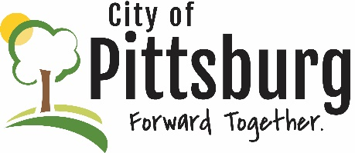
Sustainability Advisory Committee
Agenda
February 10, 2021 5:30PM
Meeting location: Online https://global.gotomeeting.com/join/412485261
Welcome and introductions
Approval of the Agenda
Approval of Meeting Notes
OLD BUSINESS
Recycling Center
City/County Recycling Support
City and County Pandemic Response
City’s New Wastewater Treatment Plant
Aquaponics Project – USD247 Progress
Public Transportation
SAC Membership
NEW BUSINESS
Earth Day 2021
OTHER BUSINESS

