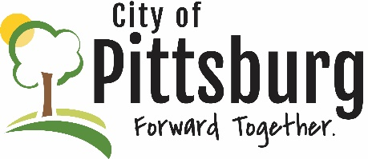
Sustainability Advisory Committee
Agenda
June 10, 2020 5:30PM
Meeting location: Online https://global.gotomeeting.com/join/598525245
Welcome and introductions
Approval of the Agenda
Approval of Minutes

OLD BUSINESS
Update on Recycling Center and potential SAC support
City and County Pandemic Response

NEW BUSINESS
Grant Opportunities (https://www.farmers.gov/manage/urban/opportunities)
Update on City’s new Wastewater Treatment Plant
Gas tax and potential endorsement

OTHER BUSINESS

