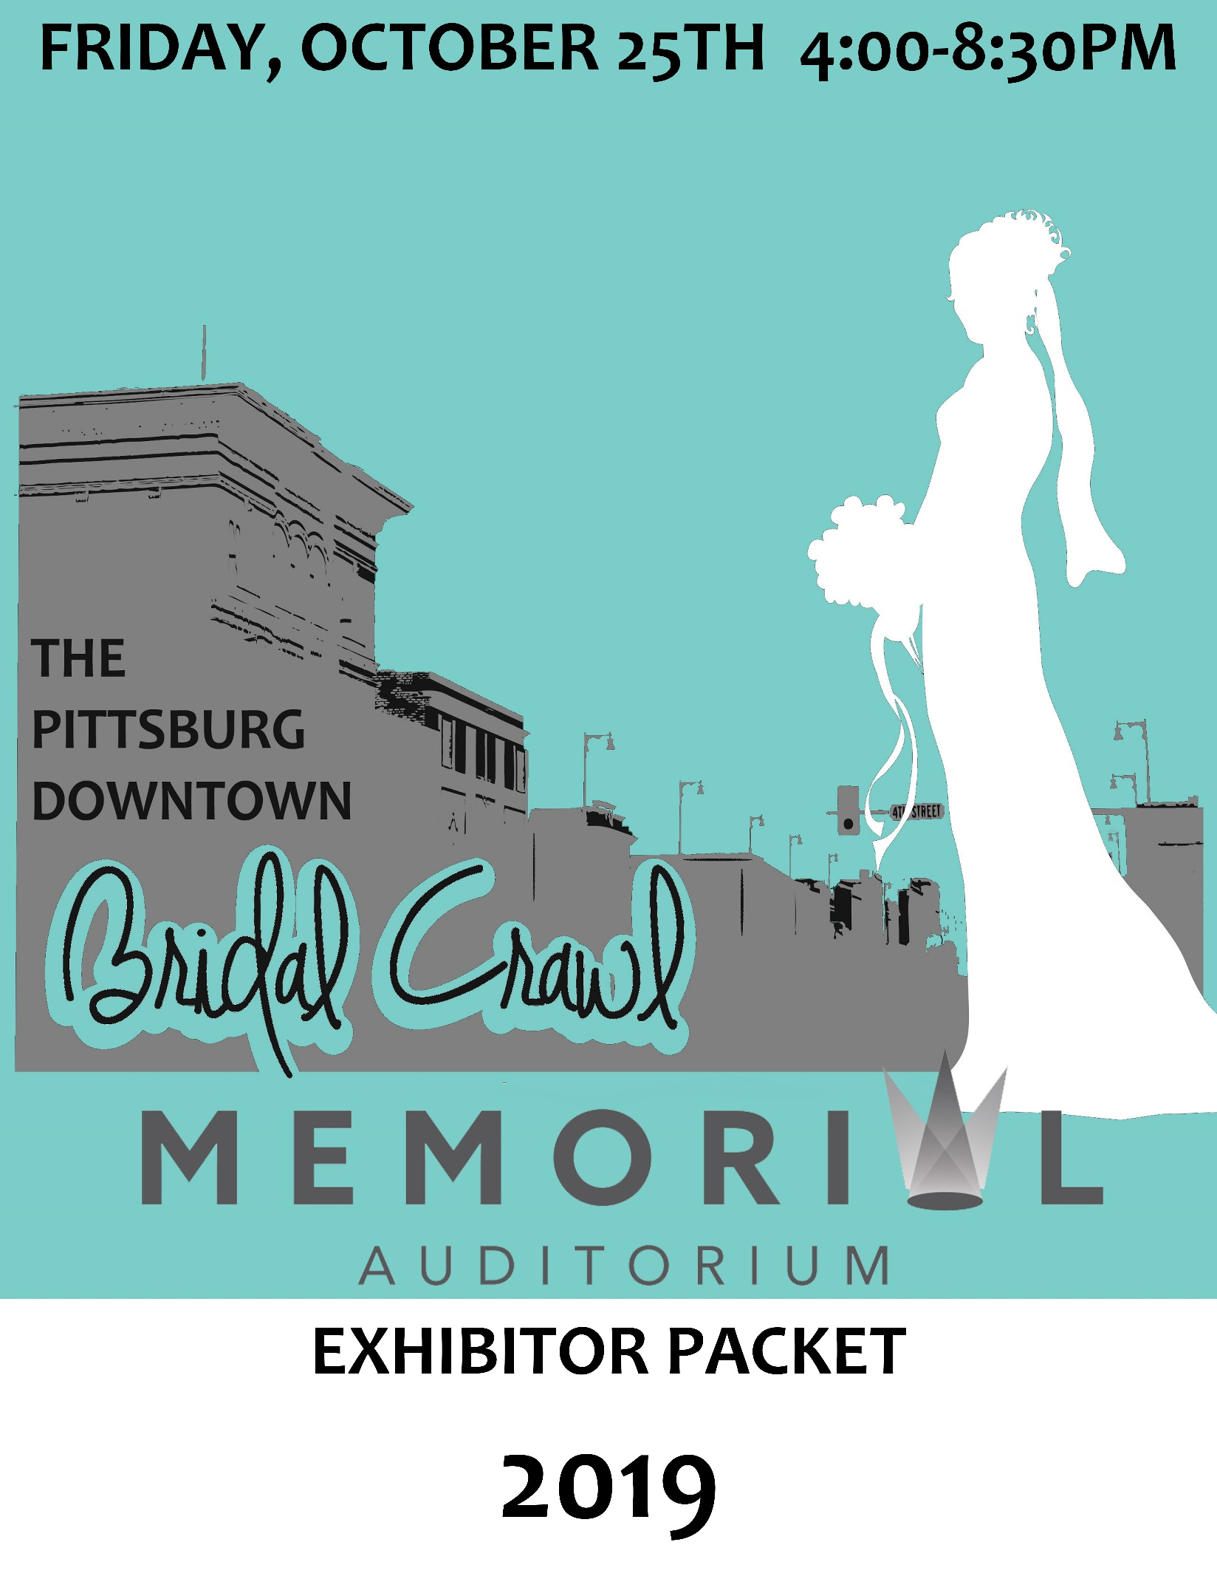
2019 Pittsburg Bridal Crawl
Friday, October 25, 2019

4:00-8:00 p.m.

Memorial Auditorium & Convention Center

Join us for an exciting evening of exhibitors & storefront businesses coming together for the 4th Annual Pittsburg Bridal Crawl! Potential customers will collect product literature, sample and view products, and visit downtown locations.

Here’s how it works and what’s included:
- Complete and return this form with payment by Oct. 14 to maccinfo@pittks.org or Memorial Auditorium at 503 N. Pine to participate or call 620-231-7827.
- Send a digital version of your logo, if you have one, to maccinfo@pittks.org.
- On October 25, each event attendees will receive a punch card with your business name or logo included. Each event attendee will visit every participating business to get their card punched to complete the Bridal Crawl and be entered into drawings at the end of the event.
- Caterers Logo’s will be on the passport, but do not need to be punched due to the food sampling not starting until 6:30pm
- Your business name or logo and product photos will be advertised within local and surrounding area newspapers, magazines, radio station, E-blasts, posters, and digital/social media outlets.
- Your storefront business will receive a Bridal Crawl 2019 window cling to show your support of the event and so event attendees can easily recognize the business locations on their punch cards.
- You may want to host an in-store promotion or giveaway during the Bridal Crawl. Let us know what your plans are, and we will help publicize!
- You may contribute business cards, literature, or other small promotional items to the giveaway bags distributed to each event attendee at the beginning of the event.

Sponsorship Packages

Main Event SPONSOR: (Limit to eight per year)
*Logo featured on all promotional advertising including: Newspaper, Magazine, Radio, Social Media, Website, E-Blast, Passports, Posters, and Banners
*$350 in prize value for the Bridal Crawl Passport Give-A-Way at the end of the event. Give-a-way items will be promoted as well.
*Logo listed on Passport. Every attendee must visit every exhibitor to be entered into grand prize drawings.

$350

$100
Storefront Exhibitor: (must be located in downtown district of Pittsburg, KS)
*Business listed on promotional advertising. May include: Newspaper, Magazine, Radio, Social Media, Website, and E-Blast.
*Logo listed on Passport. Every attendee must visit every exhibitor to be entered into grand prize drawings.
MACC Exhibitor: (includes 8’ table with black tablecloth and skirting & 2 chairs)
*Business listed on promotional advertising. May include: Newspaper, Magazine, Radio, Social Media, Website, and E-Blast.
*Logo listed on Passport. Every attendee must visit every exhibitor to be entered into grand prize drawings.
$100
Bridal Crawl Bag:
*Business may insert promotional items including, but not limited to:
Business cards, brochures, pens, note pads, and coupons.
*Every attendee will receive a Bridal Crawl Bag
$50
Caterer: (food samples for 150 guest)
*Business listed on promotional advertising. May include: Newspaper, Magazine, Radio, Social Media, Website, and E-Blast.
*Logo listed on Passport. Every attendee must be present at the Faux Reception to win grand prize drawings.
FOOD

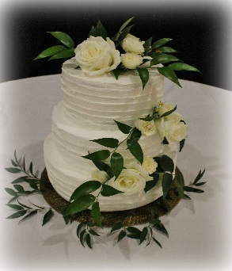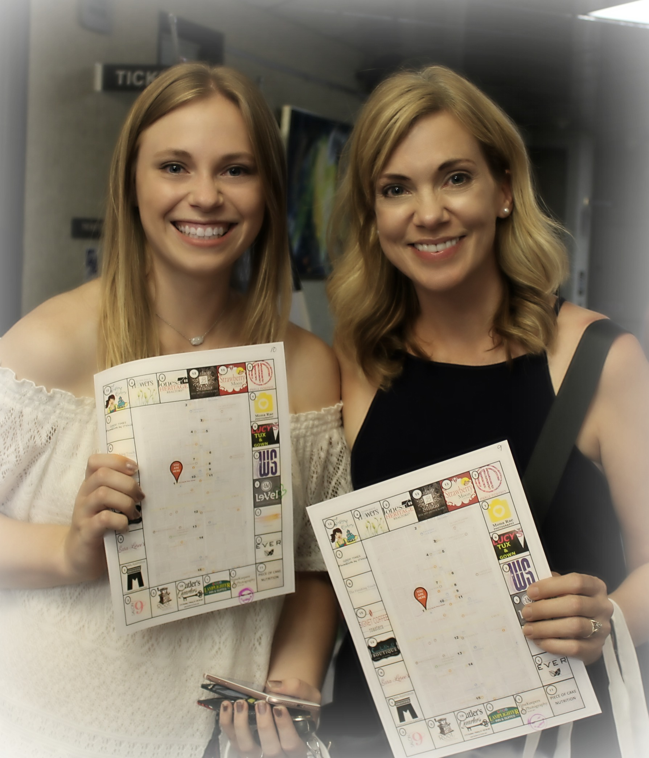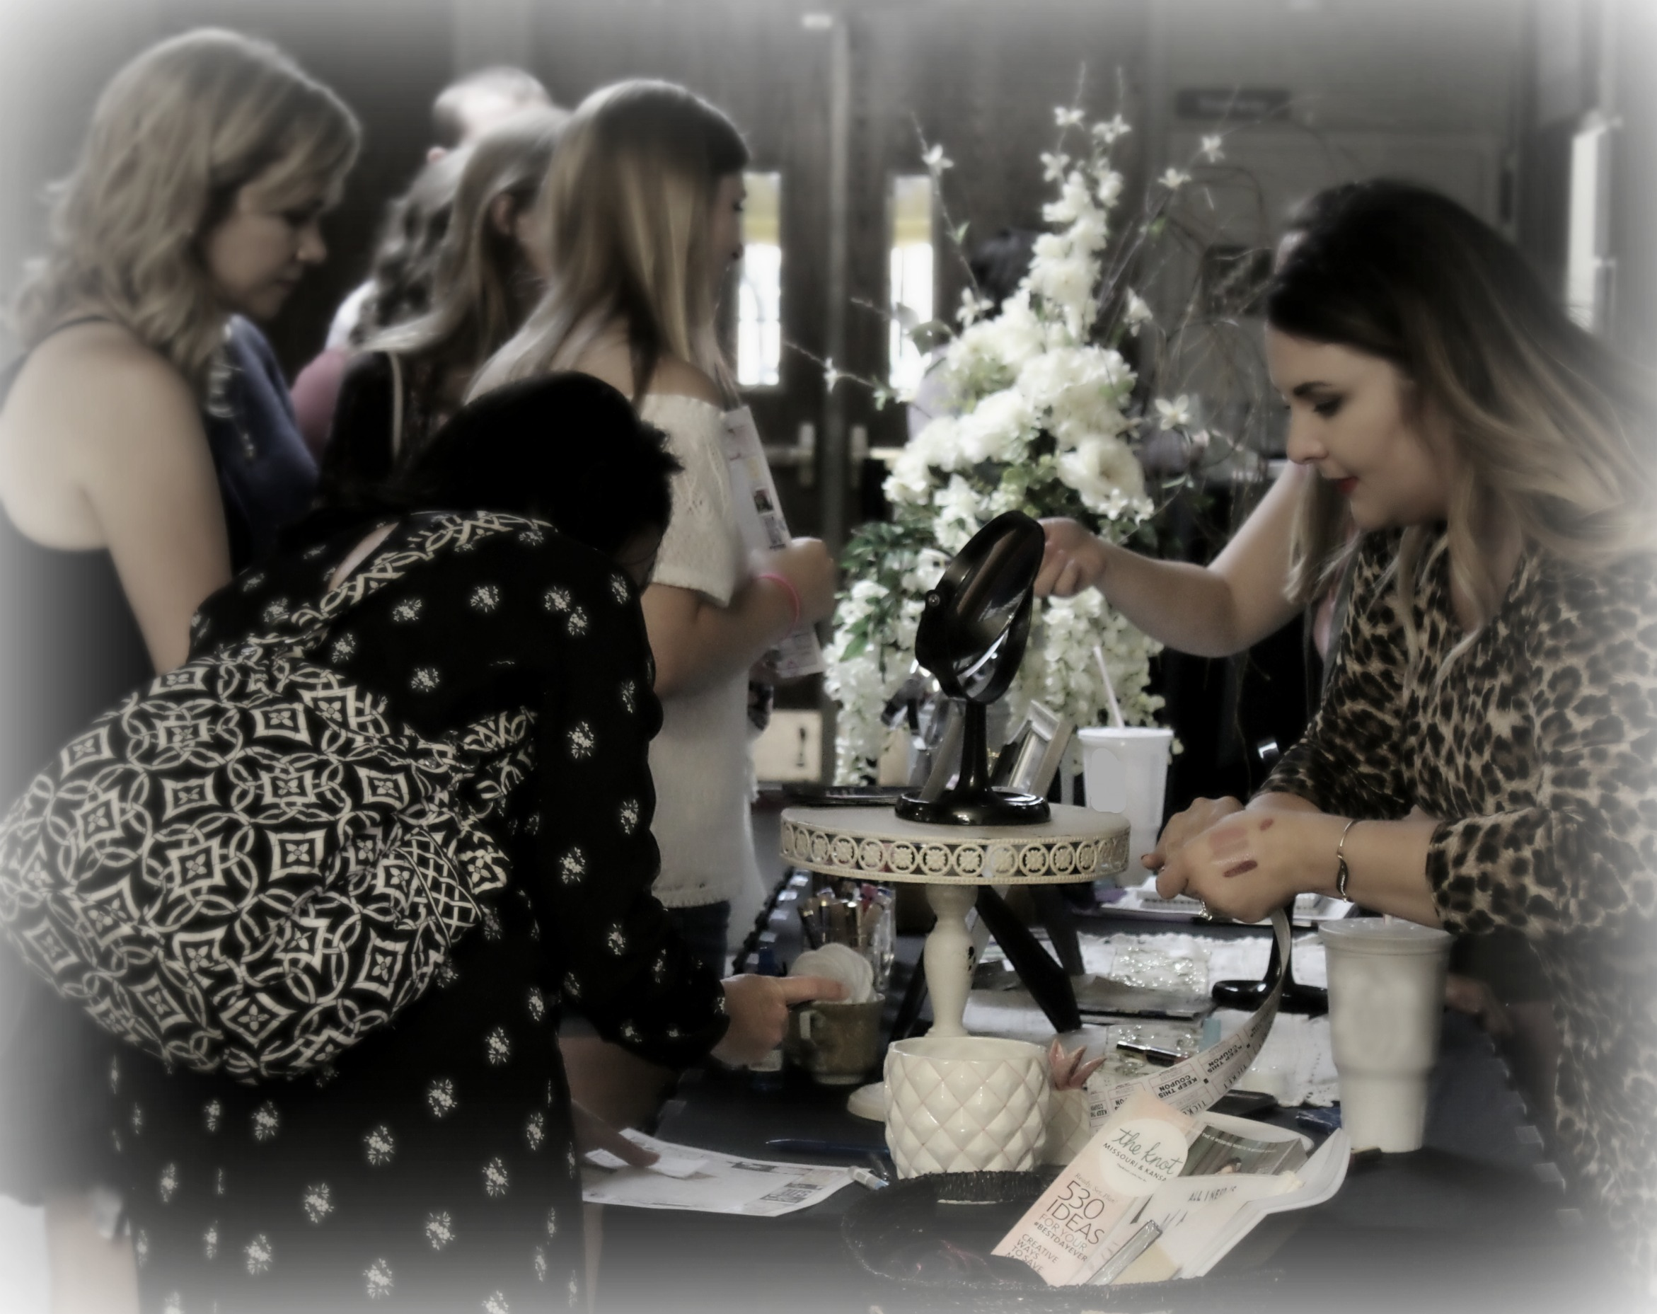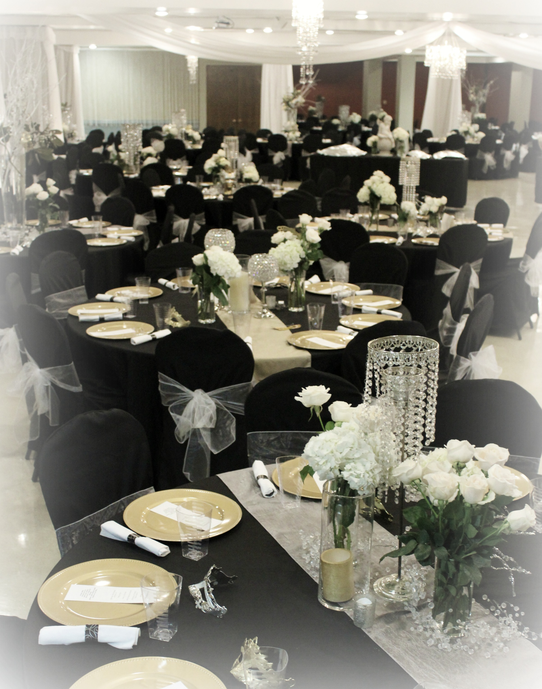
2019 Bridal Crawl Timeline

- Monday, October 14th by 5pm – All exhibitor and storefront applications and fees must be submitted to the Pittsburg Memorial Auditorium – 503 N. Pine, Pittsburg, KS 66762 – 620-231-7827

- Friday, October 25th

- 11am-4pm – Exhibitor Setup at the Memorial Auditorium.

- 4pm-6:30pm – Attendees Registration (they will receive a passport)

- 4pm-7:30pm – Exhibitor & Storefront Business will be open for Bridal Crawl

- 5:00pm – Kitchen will be open for Caterers to start bringing sample food items

- 6:30pm -- Caterers will need to have samples out on the buffet tables

- 7:30pm-8:30pm – Faux Reception in Lower Level of the Memorial Auditorium

- 8pm – Prize Drawing Starts

- 8:30 pm – End of Event
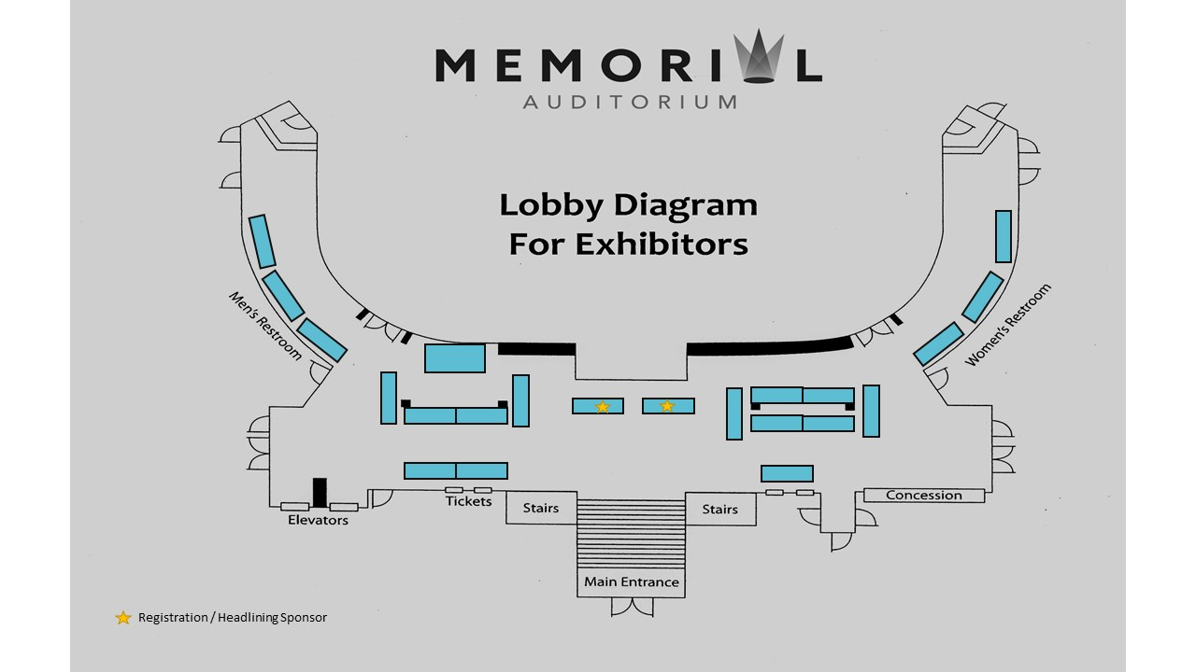
Registration

Forms and payment must be submitted by August 17th

Main Event Sponsor $350 Give-a-way (limited available/must call before October 7)
Downtown Business $100 Exhibitor at MACC $100 Promotional Bag Only $50
Caterer (food samples to serve 150 guests)

COMPANY: ________________________________________________________________________________________

CONTACT PERSON: ____________________________________________ PHONE: _______________________________

ADDRESS: ____________________________________________City:_________________________State:____________

EMAIL: _________________________________________ WEBSITE: __________________________________________

SOCIAL MEDIA INFO: _________________________________________________________________________________

What promotional activities will you be doing at your Storefront / Exhibitor space? Please list:

__________________________________________________________________________________________________

Would you like to donate a prize to be given away and the closing of the events main prize drawing?

If so, list item(s):_____________________________________________________________________________________

Would you like to participate in adding literature or promotional prizes to giveaway bags?

If so, list item(s):_____________________________________________________________________________________

*Caterers: Please Select Item: Appetizer Entre Dessert

Food Description: ___________________________________________________________________________________

Total Payment Amount Submitted: ____________________________________________

Company Signature ____________________________________________________ Date ________________________

Submit the form to maccinfo@pittks.org or mail or return to Memorial Auditorium.
Make Checks payable to: Memorial Auditorium 503 N. Pine Pittsburg, KS 66762.
Credit card payments can be made by calling 620-231-7827.
Memorial Auditorium & Convention Center • www.bridalcrawlpitt.com
Like us on Facebook: facebook.com/BridalCrawlPitt

