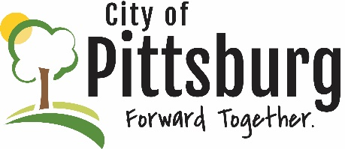
Sustainability Advisory Committee
Agenda
November 14, 2018 5:30PM
Meeting location: City Hall
OLD BUSINESS
- Confirm 10/10/18 Minutes
- Updates on the following items-
  - Climate + Energy Project Event
  - SAC facebook page
  - Electric Utility
  - Land Use Plan
Adoption of Bylaws
Election of Officers
Review Priorities
NEW BUSINESS
Education
Sustainable Food Economy
OTHER BUSINESS

