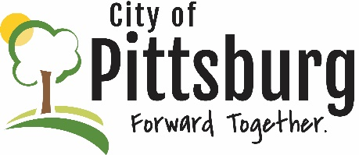
Sustainability Advisory Committee
October 10, 2018 5:30PM Agenda
Meeting location: City Hall
OLD BUSINESS
- Confirm 9/12/18 Minutes
- Updates on the following items-
  - SEK Recycling Center
  - Styrofoam condenser
Climate and Energy Project

NEW BUSINESS
Adoption of Bylaws
Election of Officers
Priority Issues / Key Initiatives for 2019

OTHER BUSINESS

